# AcqManager

# CoRegist (Digitize sensor/electrode position and Fiducial Points)

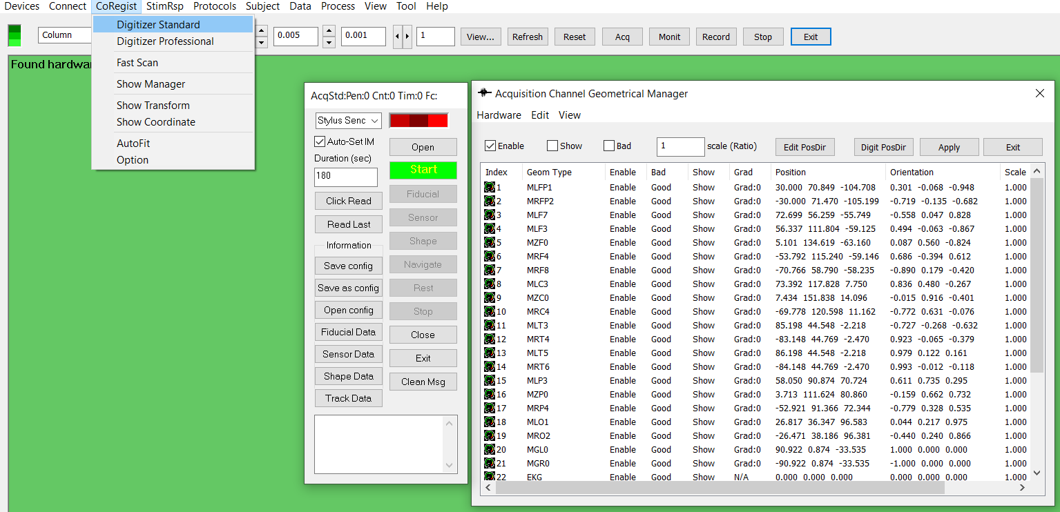

# DISCLAIMER

Software develops quickly to take the advantages of hardware and new algorithms. We have used reasonable effort to include accurate and up-to-date information in this manual; it does not, however, make any warranties, conditions or representations as to its accuracy or completeness. We assume no liability or responsibility for any errors or omissions in the content of this manual. Your use of this manual is at your own risk. Under no circumstances and under no legal theory shall the authors be liable for any indirect, direct, special, incidental, punitive, exemplary, aggravated or consequential damages arising from your use of this manual.

Features and specifications of this software program are subject to change without notice. This manual contains information and images about AcqManager, its user interface, GUI and its other signal processing algorithms, publications that are protected by copyright.

All rights reserved. This publication may be reproduced, stored in a retrieval system, or transmitted, in any form or by any means, electronic, mechanical, photocopying, recording, or otherwise, with prior permission by the authors.

*Sending Your Comments and Critiques:* We’d like to hear from you. Your comments and suggestions for improving this document are welcome and appreciated. Please e-mail your feedback to support@mecurer.com

Thank you.

Contents

AcqManager 1

CoRegist (Digitize sensor/electrode position and Fiducial Points) 1

DISCLAIMER 2

Contents 3

*Warnings and Cautions* 4

Preface 5

Co-Registration 6

Digitize Standard 6

Digitizer Professional 7

Fast Scan 8

Show Manager (of digitized points and datasets) 8

Transform 8

**Coordinate** 9

**Auto fit** 9

**Options** 9

Alignment 10

Display Settings 10

# *Warnings and Cautions*

This software supports data acquisition for magnetoencephalography (MEG), electroencephalography (EEG) and other bioelectromagnetic signals. Though MEG and EEG waveforms appear similar, they have different unit in amplitude. If the MEG and EEG data recorded simultaneously, their time unit or temporal resolution is typically the same.

Modern MEG/EEG systems typically have MEG/EEG sensor/electrode channels as well as other channels. For example, trigger channel, head-localization channels and additional ADC (analog-to-digital) channels. To avoid problems, please pay attention to the channel names and the amplitude value/unit. Their values may be of different orders of magnitude. Unexpected results may occur if their values are mixed in measurements.

When performing waveform analysis, regardless of whether MEG or EEG or both are displayed, ensure that the data are appropriately filtered with DC-offset/linear-trend removal. If the waveforms had very large amplitude (e.g. > 3 pt), it is recommended that you identify possible noise.

There are a set of source localization algorithms in the program. Each source localization algorithm has been designed and tested for specific reasons. To ensure the quality and visibility, all source localization algorithms will generate a volumetric source image, which can be considered as an image with millions of “dipoles” or multi-value-voxel, which is significantly different from the conventional magnetic source imaging (MSI) or equivalent current dipoles.

Head movement during MEG recordings may affect the accuracy of source imaging. If subjects move too much during MEG recordings, the MEG results are more than likely poor.

The accuracy of the structural images (MRI/CT) may also affect the MEG results if the conventional magnetic source imaging (MSI) is used. If MRI/CT is distorted, the combination of MEG/MRI/CT will be low-quality. In addition, multiple local sphere, head model or other structural constrained source localization my internally use the MRI/CT images. Any analysis based on those distorted images may yield unexpected or poor results.

The following warnings and cautions appear in this guide. Please ensure you are aware of all the operations and interpretations.

# Preface

The Main Frame is one of the core windows of AcqManager software. It is used as the primary tool to view MEG, EEG, MCG, ECG, triggers and other data, mark and classify the data, and identify results of interest for academic or clinical purposes. Importantly, the Main Frame provides graphic user interface (GUI) for access other function. In other words, it is also often used to launch other windows such as source localization.

This guide describes the operation of the AcqManager application for MEG/EEG/MCG/ECG. Though there are many functions related to MRI/CT, analyses of MRI/CT are not the focuses of this guide.

*Determining the Software Version*

In the Main Frame: select Help -> About.

The About Dialog will show the version of the software.

*Intended Audience*

This guide is intended for anyone needing to record and view (online) data with an appropriate hardware system. It assumes the technologist/operator is familiar with standard MEG/EEG/MCG/ECG procedures and with the Windows operating systems.

*Document Structure*

Documents are generally provided in both Microsoft Word® format and Adobe® Acrobat® PDF (Portable Document Format). All editions are distributed on Flash Driver, CD or websites with the related software, and include bookmarks and hyperlinks to assist navigating the document. Please feel free to send your critiques, corrections, suggestions and comments to support@mecurer.com.

*Conventions*

Numeric: Numeric values are generally presented in decimal but in special circumstances may also be expressed in hexadecimal or binary. Hexadecimal values are shown with a prefix of 0x, in the form 0x3D. Binary values are shown with a prefix of 0b, in the form 0b00111101. Otherwise, values are presumed decimal.

Units: Units of measure are given in metric. Where measure is provided in imperial units, they are typically shown in parenthesis after the metric units. Biomagnetic signal strength is given in Teslas (T), the SI unit of flux density (or field intensity) for magnetic fields, also known as the magnetic induction. Typical signal strengths in biomagnetic measurements are in the order of pT (picoteslas = 10-12) or fT (femtoteslas = 10-15). Electrical signal strength is given in volts (V). Bioelectrical activity is typically quite small, measured in microvolts (mV).

# Co-Registration

The current standard co-registration method in MEG relies on the combination of head position indicator (HPI) coils attached to the participant’s head and a pen-like electromagnetic 3D digitiser. Prior to MEG measurements, the positions of the HPI coils as well as a set of anatomical landmarks on the head are digitised. To localise the HPI coils with respect to the MEG sensors, known currents are driven into the coils either sequentially or at different frequencies prior to or continuously during MEG measurements and a magnetic dipole model representing each coil is fitted to the acquired MEG sensor signals. Finally, the actual co-registration is performed by aligning the HPI-coil locations as determined by the MEG system with those determined by digitisation, and aligning the digitised anatomical landmarks with the same landmarks in the structural image (e.g., MR image). The accuracy of the co-registration can be improved by digitising not only the landmarks but a larger set of points on the head surface. Due to the need to manually digitise each point, their number is limited. For the same reason, the number of HPI coils is typically no more than 5. However, with optical scanning methods, one can obtain several orders of magnitude more points in less time than used with current methods. Additionally, the accurate localisation of the HPI coils requires a MEG sensor array with extensive coverage and a large number of channels. Thus, using HPI coils with the current, early-stage on-scalp MEG systems with only a few channels is not feasible.

AcqManager provide the functionalities to digitize magnetic sensors, electrodes and fiducial points. In addition, AcqManager also enables users to digitize the head shape and more.

# Digitize Standard

The software supports an increasing list of methods for digitizing magnetic sensors, electrodes and fiducial points. One of the commonly used digitization devices is Polhemus Fastrak. Using Polhemus technology, AcqManager is able produce a three dimensional image of a subject's head and define the exact location of OPM sensors or electrodes placed on the subject. By using AcqManager, you can quickly take MEG/EEG data and overlay it on a MR image for an exact definition of where electrical or magnetic activity is coming. Without using AcqManager and Polhemus solutions, this is a long and difficult process to accurately calculate this activity.

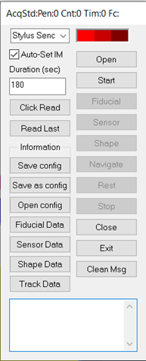

Figure 1. Stylus Digitizer.

# Digitizer Professional

Digitizer Profession provides additional control of the digitization hardware. For example, Polhemus is one of the heardware for digitizing products in the market. Polhemus digitizers are easy-to-use with systems that allow you to move freely--around, under and behind objects--and have the capability to digitize both big and small items. You can digitize everything from MEG sensors, EEG electrodes, shape, fiducial markers and special land points. The position of digitized point enable the co-register functional MEG and EEG data to accurately localize brain activity. The pinpoint accurate stylus is tracked by using Polhemus proprietary technology, utilizing AC Electromagnetics. We offer high-end, full 6DOF digitizers that won't break your budget.

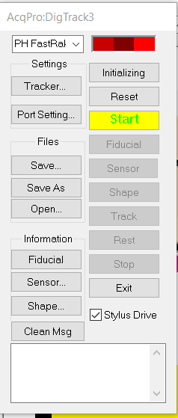

Figure 2. Professional Digitization.

# Fast Scan

AcqManager also supports a co-registration method that employs commercial, consumer-grade structured-light scanners that are suitable for an on-scalp MEG system with a partially rigid sensor array. It has been tested that the co-registration method both in terms of reproducibility and accuracy, using phantom measurements as well as a human experiment. There are many types of light scanner. One type of scanners has been tested is a consumer-grade structured-light scanner (Occipital Inc., San Francisco, CA, USA) to digitise the head surface of the subject as well as the MEG sensor helmet. The structured-light scanner functions by projecting a pattern of infrared light onto an object, which is then detected by a camera at a known distance from the projector. The three-dimensional shape of the scanned object can then be determined based on the apparent distortion of the pattern as seen by the camera. The scanner captures both colour and depth data at a frame rate of 30 Hz, with each frame being co-registered to the previous one in real time. The scanner is connected to computer which can both function as an operator display and compute the digitised surface mesh in real time. At a typical working distance of 50 cm, the scanner has a vendor-specified point accuracy of 0.8 mm.

# Show Manager (of digitized points and datasets)

AcqManager provides a GUI for you to manager multiple digitization (e.g., multi-tests) data sets for one subject or multiple datasets for more than one subjects.

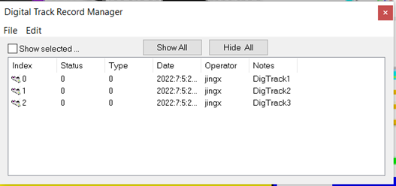

Figure 3. Manager of Digitization Datasets.

# Transform

This menu invokes a window and let you change the co-ordinate of the digitalized system.

You can reverse and exchange X, Y and Z coordinates by clicking the corresponding buttons. Basically, it changes the orientation of the digitalized data.

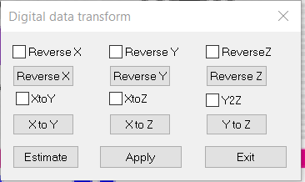

Figure 4. Transformation of Digitized Points for Co-registration.

**Coordinate**

The coordinate function is used for changing the location and orientation of the digitalized data. It is different from the transform that changes the orientation of axes.

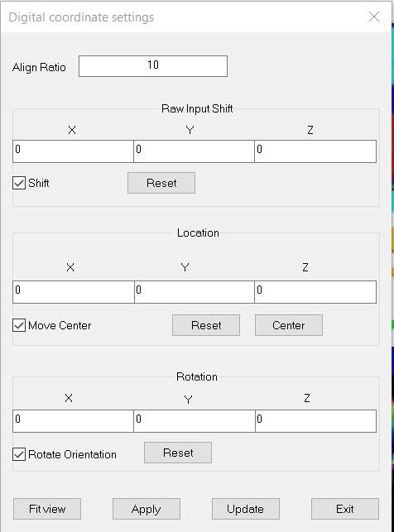

Figure 5. Coordination of Digitized Points for Co-registration.

**Auto fit**

The Autofit function will fit the digitalized data in the view.

**Options**

The options provide a user interface for changing the display. You can display the digitalized data as point, cube or sphere by selecting the radio buttons.

# Alignment

This function allows user to adjust the align ration of the digital data by pressing the left mouse button and move. This is commonly used to change the unit between the software and the hardware, or to correct nose.

# Display Settings

AcqManager provides a GUI for visualizing digitized points. Please note the tracking point is the recently digitalized point. This function allows user to adjust size and expected extending of the tracking Arrow. Tracking Arrow needs two points, the arrow is pointing from the last one to the previous one.

**Index**

E

Electroencephalography (EEG), **5**

F

femtoteslas, 6

M

Magnetic source imaging (MSI), 5

Magnetoencephalography (MEG), 5

Main Frame, 6

P

picoteslas, 6

T

Teslas (T),, 6